Backflow Prevention Assemblies

Landscape Irrigation: RP, RPZ, RPBA Reduced Pressure Principle Backflow Prevention Assembly
Some typical hazards posed by an irrigation system are:
- Organisms (parasites, insect larvae, pathogens) living in the water of the irrigation system.
- Exposure of the sprinkler heads to fertilizers, herbicides, or pesticides in the yard.
- Exposure of the sprinkler heads to fecal material from animals living on the site (dogs, cats, rodents, farm animals).
- Direct connection of chemical additives to the irrigation system.
- Connection of alternative water sources (creeks, rainwater harvesting systems, lakes, private wells, stock tanks, etc.).
Requirements:

- In Walnut Creek SUD all irrigation systems are installed on sites that have an on-site sewage facility (septic tank). The existence of the OSSF elevates the classification of the irrigation system to a health hazard requiring the installation of an RP.
Testing:
- RP, RPZ, RPBA are required to be tested upon installation and annually thereafter. Copies of these tests are to be filled at the District’s office.
Since before 2009 a Double-Check Valve Assembly was allowed on irrigation systems installed on sites that also had an OSSF. As a result there are currently installed systems that do not have the correct backflow prevention assembly. To correct this if the Double Check valve requires any major maintenance, alteration, repair, or service they cannot be repaired and must be upgraded to the required RP.
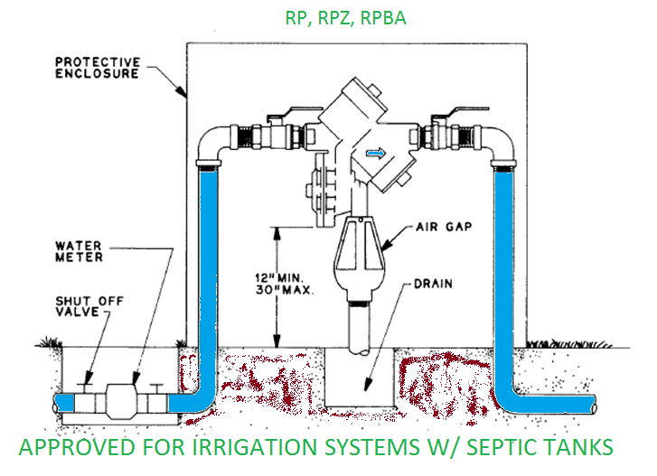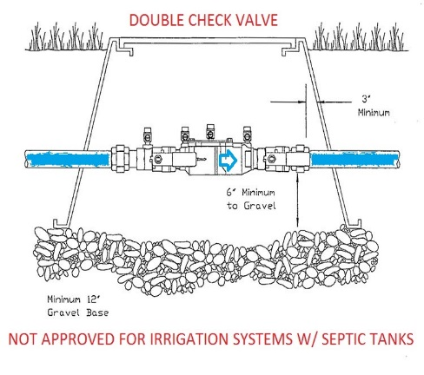

Outside Faucets: HBVB (hose bibb vacuum breaker), anti-siphon faucet
Some typical hazards posed by garden hose are:
- Lawn care aspirators for herbicide, pesticide, and fertilizer application (miracle grow).
- Pressure washing equipment for carpet and automotive cleaners.
- Forcing it into a clogged gutter, downspout, or sewer pipe to flush out the clog
- Letting the end of the hose be submerged in a puddle, bucket, water through, or swimming pools.
Requirements:
- For this reason all outside faucets are required to either have a HBVB or an anti-siphon faucet installed.

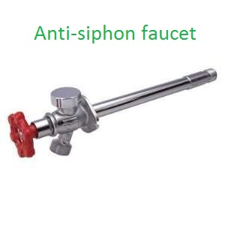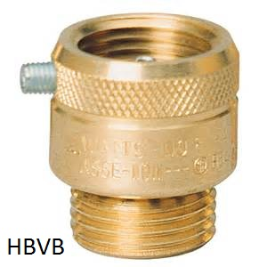

RV Parks: RP, RPZ, RPBA (Reduced Pressure Principle Backflow Prevention Assembly), PVB, SVB

Some typical hazards posed by RV parks:
- Many RVs are sold today with a “sewer flusher” connection which allows the blackwater tank to be flushed.
- “Y Hose Adapters” which enable an RV owner to establish connections from a potable water hose bibb to both the RV’s potable water systems and sewer flusher connection at the same time.

Requirements:

- RV parks are considered a health hazard do to the potential associated with blackwater tank flushing so a RP is to be install at the meter.
- Any faucets where flushing is allowed must have a PVB or SVB installed.
- If the RV park currently has a DC (double check valve) installed it cannot be repaired and must be upgraded to a RP.
Testing:
- RP and PVB, SVB are required to be tested upon installation and annually thereafter. .
- Current DCs installed must be tested annually.
COPIES OF ALL BACKFLOW PREVENTION ASSEMBLIES MUST BE FILLED WITH THE DISTRICT’S OFFICE.

